Table 2

Gerko Vink

Mean score and prevalence^^ of Questionable Research Practices (QRP), Falsification, and Fabrication stratified by Disciplinary Field and Academic Rank

Table of Contents

# Packages used

For this document we use the following packages

library(dplyr) # Data manipulation  
library(mice) # Data imputation  
library(magrittr) # Pipes  
library(purrr) # Functional programming  
library(haven) # Import data  
library(DT) # Interactive tables  
library(ggplot2) # Plotting device  
library(reshape2) # Data shaping  
library(labelled) # Advanced labelling  
library(psych) # Descriptive tables  
library(tibble) # Tibbles  
library(RRreg) # Randomized Response

# Load the data

load(file = "../Workspaces/5. Preparation Imputed Datasets.Rdata")  
options(DT.options = list(pageLength = 50)) # table options

# Means

## No id variables; using all as measure variables

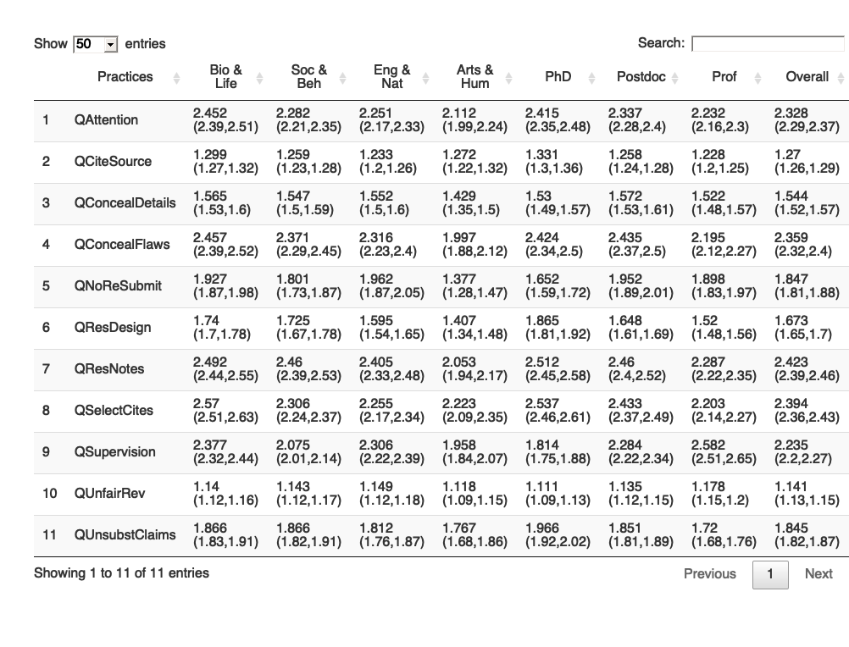

## Practices Bio & Life Soc & Beh Eng & Nat  
## 1 QAttention 2.452 (2.39,2.51) 2.282 (2.21,2.35) 2.251 (2.17,2.33)  
## 2 QCiteSource 1.299 (1.27,1.32) 1.259 (1.23,1.28) 1.233 (1.2,1.26)  
## 3 QConcealDetails 1.565 (1.53,1.6) 1.547 (1.5,1.59) 1.552 (1.5,1.6)  
## 4 QConcealFlaws 2.457 (2.39,2.52) 2.371 (2.29,2.45) 2.316 (2.23,2.4)  
## 5 QNoReSubmit 1.927 (1.87,1.98) 1.801 (1.73,1.87) 1.962 (1.87,2.05)  
## 6 QResDesign 1.74 (1.7,1.78) 1.725 (1.67,1.78) 1.595 (1.54,1.65)  
## 7 QResNotes 2.492 (2.44,2.55) 2.46 (2.39,2.53) 2.405 (2.33,2.48)  
## 8 QSelectCites 2.57 (2.51,2.63) 2.306 (2.24,2.37) 2.255 (2.17,2.34)  
## 9 QSupervision 2.377 (2.32,2.44) 2.075 (2.01,2.14) 2.306 (2.22,2.39)  
## 10 QUnfairRev 1.14 (1.12,1.16) 1.143 (1.12,1.17) 1.149 (1.12,1.18)  
## 11 QUnsubstClaims 1.866 (1.83,1.91) 1.866 (1.82,1.91) 1.812 (1.76,1.87)  
## Arts & Hum PhD Postdoc Prof  
## 1 2.112 (1.99,2.24) 2.415 (2.35,2.48) 2.337 (2.28,2.4) 2.232 (2.16,2.3)  
## 2 1.272 (1.22,1.32) 1.331 (1.3,1.36) 1.258 (1.24,1.28) 1.228 (1.2,1.25)  
## 3 1.429 (1.35,1.5) 1.53 (1.49,1.57) 1.572 (1.53,1.61) 1.522 (1.48,1.57)  
## 4 1.997 (1.88,2.12) 2.424 (2.34,2.5) 2.435 (2.37,2.5) 2.195 (2.12,2.27)  
## 5 1.377 (1.28,1.47) 1.652 (1.59,1.72) 1.952 (1.89,2.01) 1.898 (1.83,1.97)  
## 6 1.407 (1.34,1.48) 1.865 (1.81,1.92) 1.648 (1.61,1.69) 1.52 (1.48,1.56)  
## 7 2.053 (1.94,2.17) 2.512 (2.45,2.58) 2.46 (2.4,2.52) 2.287 (2.22,2.35)  
## 8 2.223 (2.09,2.35) 2.537 (2.46,2.61) 2.433 (2.37,2.49) 2.203 (2.14,2.27)  
## 9 1.958 (1.84,2.07) 1.814 (1.75,1.88) 2.284 (2.22,2.34) 2.582 (2.51,2.65)  
## 10 1.118 (1.09,1.15) 1.111 (1.09,1.13) 1.135 (1.12,1.15) 1.178 (1.15,1.2)  
## 11 1.767 (1.68,1.86) 1.966 (1.92,2.02) 1.851 (1.81,1.89) 1.72 (1.68,1.76)  
## Overall  
## 1 2.328 (2.29,2.37)  
## 2 1.27 (1.26,1.29)  
## 3 1.544 (1.52,1.57)  
## 4 2.359 (2.32,2.4)  
## 5 1.847 (1.81,1.88)  
## 6 1.673 (1.65,1.7)  
## 7 2.423 (2.39,2.46)  
## 8 2.394 (2.36,2.43)  
## 9 2.235 (2.2,2.27)  
## 10 1.141 (1.13,1.15)  
## 11 1.845 (1.82,1.87)

# Prevalence of QRP items

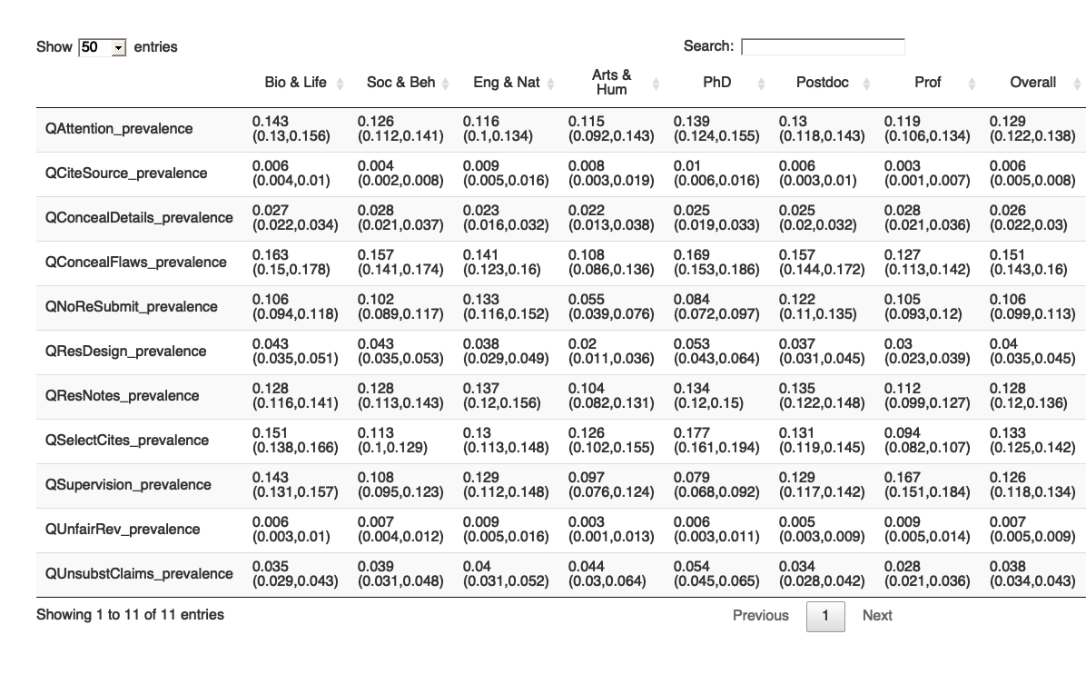

## Bio & Life Soc & Beh  
## QAttention_prevalence 0.143 (0.13,0.156) 0.126 (0.112,0.141)  
## QCiteSource_prevalence 0.006 (0.004,0.01) 0.004 (0.002,0.008)  
## QConcealDetails_prevalence 0.027 (0.022,0.034) 0.028 (0.021,0.037)  
## QConcealFlaws_prevalence 0.163 (0.15,0.178) 0.157 (0.141,0.174)  
## QNoReSubmit_prevalence 0.106 (0.094,0.118) 0.102 (0.089,0.117)  
## QResDesign_prevalence 0.043 (0.035,0.051) 0.043 (0.035,0.053)  
## QResNotes_prevalence 0.128 (0.116,0.141) 0.128 (0.113,0.143)  
## QSelectCites_prevalence 0.151 (0.138,0.166) 0.113 (0.1,0.129)  
## QSupervision_prevalence 0.143 (0.131,0.157) 0.108 (0.095,0.123)  
## QUnfairRev_prevalence 0.006 (0.003,0.01) 0.007 (0.004,0.012)  
## QUnsubstClaims_prevalence 0.035 (0.029,0.043) 0.039 (0.031,0.048)  
## Eng & Nat Arts & Hum  
## QAttention_prevalence 0.116 (0.1,0.134) 0.115 (0.092,0.143)  
## QCiteSource_prevalence 0.009 (0.005,0.016) 0.008 (0.003,0.019)  
## QConcealDetails_prevalence 0.023 (0.016,0.032) 0.022 (0.013,0.038)  
## QConcealFlaws_prevalence 0.141 (0.123,0.16) 0.108 (0.086,0.136)  
## QNoReSubmit_prevalence 0.133 (0.116,0.152) 0.055 (0.039,0.076)  
## QResDesign_prevalence 0.038 (0.029,0.049) 0.02 (0.011,0.036)  
## QResNotes_prevalence 0.137 (0.12,0.156) 0.104 (0.082,0.131)  
## QSelectCites_prevalence 0.13 (0.113,0.148) 0.126 (0.102,0.155)  
## QSupervision_prevalence 0.129 (0.112,0.148) 0.097 (0.076,0.124)  
## QUnfairRev_prevalence 0.009 (0.005,0.016) 0.003 (0.001,0.013)  
## QUnsubstClaims_prevalence 0.04 (0.031,0.052) 0.044 (0.03,0.064)  
## PhD Postdoc  
## QAttention_prevalence 0.139 (0.124,0.155) 0.13 (0.118,0.143)  
## QCiteSource_prevalence 0.01 (0.006,0.016) 0.006 (0.003,0.01)  
## QConcealDetails_prevalence 0.025 (0.019,0.033) 0.025 (0.02,0.032)  
## QConcealFlaws_prevalence 0.169 (0.153,0.186) 0.157 (0.144,0.172)  
## QNoReSubmit_prevalence 0.084 (0.072,0.097) 0.122 (0.11,0.135)  
## QResDesign_prevalence 0.053 (0.043,0.064) 0.037 (0.031,0.045)  
## QResNotes_prevalence 0.134 (0.12,0.15) 0.135 (0.122,0.148)  
## QSelectCites_prevalence 0.177 (0.161,0.194) 0.131 (0.119,0.145)  
## QSupervision_prevalence 0.079 (0.068,0.092) 0.129 (0.117,0.142)  
## QUnfairRev_prevalence 0.006 (0.003,0.011) 0.005 (0.003,0.009)  
## QUnsubstClaims_prevalence 0.054 (0.045,0.065) 0.034 (0.028,0.042)  
## Prof Overall  
## QAttention_prevalence 0.119 (0.106,0.134) 0.129 (0.122,0.138)  
## QCiteSource_prevalence 0.003 (0.001,0.007) 0.006 (0.005,0.008)  
## QConcealDetails_prevalence 0.028 (0.021,0.036) 0.026 (0.022,0.03)  
## QConcealFlaws_prevalence 0.127 (0.113,0.142) 0.151 (0.143,0.16)  
## QNoReSubmit_prevalence 0.105 (0.093,0.12) 0.106 (0.099,0.113)  
## QResDesign_prevalence 0.03 (0.023,0.039) 0.04 (0.035,0.045)  
## QResNotes_prevalence 0.112 (0.099,0.127) 0.128 (0.12,0.136)  
## QSelectCites_prevalence 0.094 (0.082,0.107) 0.133 (0.125,0.142)  
## QSupervision_prevalence 0.167 (0.151,0.184) 0.126 (0.118,0.134)  
## QUnfairRev_prevalence 0.009 (0.005,0.014) 0.007 (0.005,0.009)  
## QUnsubstClaims_prevalence 0.028 (0.021,0.036) 0.038 (0.034,0.043)

# Prevalence of any QRP and Randomized Response

prevalence <- merge(prev.Field, prev.Rank, by.x = "Indicator")  
cbind(prevalence, prev.overall) %>%   
 datatable()

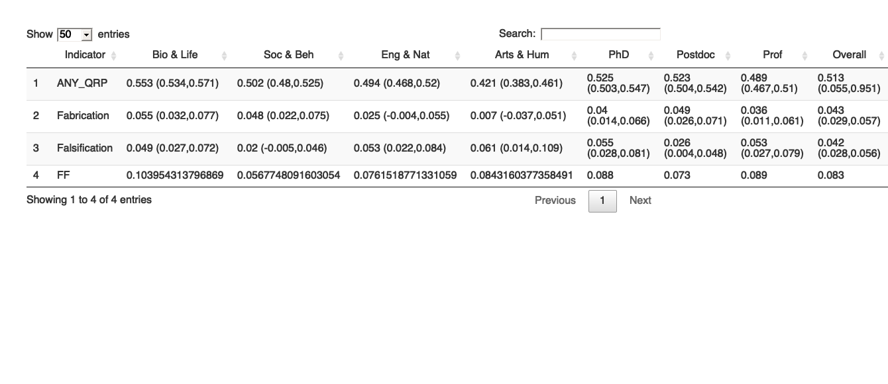

cbind(prevalence, prev.overall)

## Indicator Bio & Life Soc & Beh Eng & Nat  
## 1 ANY_QRP 0.553 (0.534,0.571) 0.502 (0.48,0.525) 0.494 (0.468,0.52)  
## 2 Fabrication 0.055 (0.032,0.077) 0.048 (0.022,0.075) 0.025 (-0.004,0.055)  
## 3 Falsification 0.049 (0.027,0.072) 0.02 (-0.005,0.046) 0.053 (0.022,0.084)  
## 4 FF 0.103954313796869 0.0567748091603054 0.0761518771331059  
## Arts & Hum PhD Postdoc  
## 1 0.421 (0.383,0.461) 0.525 (0.503,0.547) 0.523 (0.504,0.542)  
## 2 0.007 (-0.037,0.051) 0.04 (0.014,0.066) 0.049 (0.026,0.071)  
## 3 0.061 (0.014,0.109) 0.055 (0.028,0.081) 0.026 (0.004,0.048)  
## 4 0.0843160377358491 0.088 0.073  
## Prof Overall  
## 1 0.489 (0.467,0.51) 0.513 (0.055,0.951)  
## 2 0.036 (0.011,0.061) 0.043 (0.029,0.057)  
## 3 0.053 (0.027,0.079) 0.042 (0.028,0.056)  
## 4 0.089 0.083

# Session Info

sessionInfo()

## R version 4.0.4 (2021-02-15)  
## Platform: x86_64-apple-darwin17.0 (64-bit)  
## Running under: macOS Catalina 10.15.7  
##   
## Matrix products: default  
## BLAS: /Library/Frameworks/R.framework/Versions/4.0/Resources/lib/libRblas.dylib  
## LAPACK: /Library/Frameworks/R.framework/Versions/4.0/Resources/lib/libRlapack.dylib  
##   
## locale:  
## [1] en_US.UTF-8/en_US.UTF-8/en_US.UTF-8/C/en_US.UTF-8/en_US.UTF-8  
##   
## attached base packages:  
## [1] stats graphics grDevices utils datasets methods base   
##   
## other attached packages:  
## [1] RRreg_0.7.1 tibble_3.1.0 psych_2.0.12 labelled_2.7.0 reshape2_1.4.4  
## [6] ggplot2_3.3.3 DT_0.17 haven_2.3.1 purrr_0.3.4 magrittr_2.0.1  
## [11] mice_3.13.5 dplyr_1.0.5   
##   
## loaded via a namespace (and not attached):  
## [1] Rcpp_1.0.6 lattice_0.20-41 tidyr_1.1.3 ps_1.5.0   
## [5] assertthat_0.2.1 digest_0.6.27 foreach_1.5.1 utf8_1.2.1   
## [9] R6_2.5.0 plyr_1.8.6 backports_1.2.1 evaluate_0.14   
## [13] highr_0.8 pillar_1.5.1 rlang_0.4.10 minqa_1.2.4   
## [17] callr_3.5.1 nloptr_1.2.2.2 Matrix_1.3-2 rmarkdown_2.6   
## [21] splines_4.0.4 webshot_0.5.2 lme4_1.1-26 statmod_1.4.35   
## [25] stringr_1.4.0 htmlwidgets_1.5.3 munsell_0.5.0 broom_0.7.6   
## [29] compiler_4.0.4 xfun_0.21 pkgconfig_2.0.3 mnormt_2.0.2   
## [33] tmvnsim_1.0-2 htmltools_0.5.1.1 tidyselect_1.1.0 codetools_0.2-18   
## [37] fansi_0.4.2 crayon_1.4.1 withr_2.4.1 MASS_7.3-53   
## [41] grid_4.0.4 jsonlite_1.7.2 nlme_3.1-152 gtable_0.3.0   
## [45] lifecycle_1.0.0 DBI_1.1.1 scales_1.1.1 stringi_1.5.3   
## [49] debugme_1.1.0 doParallel_1.0.16 ellipsis_0.3.1 generics_0.1.0   
## [53] vctrs_0.3.7 boot_1.3-26 iterators_1.0.13 tools_4.0.4   
## [57] forcats_0.5.1 glue_1.4.2 crosstalk_1.1.1 hms_1.0.0   
## [61] processx_3.4.5 parallel_4.0.4 yaml_2.2.1 colorspace_2.0-0   
## [65] knitr_1.31

# Document info

Signed: [Gerko Vink](https://www.gerkovink.com),

timestamp()

## ##------ Tue Apr 20 21:16:25 2021 ------##

END of DOCUMENT